LLD

- What to do at first
- Analyse requirement. (find the flow)
- Define scope (method that you are going to implement in your lld)
Ex - Book my show -
- User need to search movie
- Book that movie
- Notification
- Stop it and ask them if it’s OK
- List down object
Ex - User, bookMyShowPortal, Movie, Seats, theaters
- ask interviewer
- Come up with relationship
Is-A relationship and Has-A relationship
(Inheritance and contain that object)
(Give a follow)
- Movies has theaters
- Theaters has screens
- Screen has seats

- Is a : Theater can be private and public
- Seat : can be normal and incliners (ask this to interviewer)
- Should be scalable, readable
(Example - seat’s Enum can be scaled)

- Optimize - Solid principle or design pattern

Solid principles/ Oops principle
- Single responsibility:
Class should have single responsibility
- Open/Closed:
Open for extension and closed for modification.
- EX: created a class which is full proof and tested, one more feature comes then if you add it in same then it’s chance to add a bug in already tested code. So need to do full testing
- so it should be open for extension and closed for modification
- how create a interface
- L - LiskOV substitution principle
Interface => child1, child2
Parent p = new child1();, if replaced by child2 , it should not break

Replacing child classes with another child class with same interface should be possible.
- Interface segregation
You should not force child class to implement methods
- Ex : rubber duck can not fly,
In interface, all functions should be valid for all related classes.
- Dependency inversion
- Ex: keyboard can be of many types,
- Computer has a keyboard(interface/abstract class)

- In parent class always use interface or abstract methods in constructor while using dependency injection, so while making object of that class we can say which class we want to use for that interface which can be scalable. So Dependancy injection then inversion.
Design Pattern

- Strategy design pattern
Here, look at first level of tree, in which you can see that
There are some methods which is not of parent but In child that methods are similar.
- what happen is that when we scale application, this duplication can grow also.
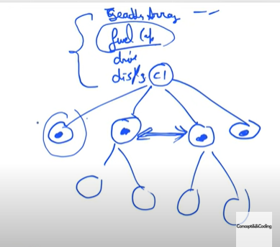
- Strategy design can help in this type of scenario.

-> Drive interface : drive()
- Normal drive interface - drive()
- Special drive interface - drive()

Classes will design which drive to use
Vehicle {
Drive obj;
// here any normal or special can be passes.
Ctor(Drive obj){
This.obj = obj;
}
}

Use when child can have same code which is not present in base class.

- Observer design pattern :

Walmart question - when going to amazon, some products are not available, there’s one feature : Notify me. Implement that.

: Observable, and observer.
- when state is changed, observable will update observer.

ObservableInterface{
List<ObserverInterface> list;
Add (ObserverInterface obs);
Remove(ObserverInterface Obs)
Notify(){
List.foreach(l=>l.update()); // make empty argument
}
SetData(){
This.notify();
}
}

ObserverInterface{
Observableinterface obsv;
Update(){
Obsv.getData()
}
}

Ex: weather station => temp ko set karna, => Tv display, mobile display
- Stocks

- Decorator pattern:

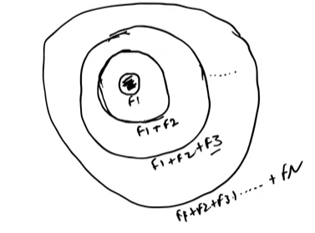
- Ex: Pizza , Add on - Cheese etc etc
Coffee, Add-on - sugar, milk, cream
Car: Add-on - cover seat, ac, power st.., fog light

: kitne different classes banaoge??

Inheriting abstract classes nth time.
Both has and is relation.

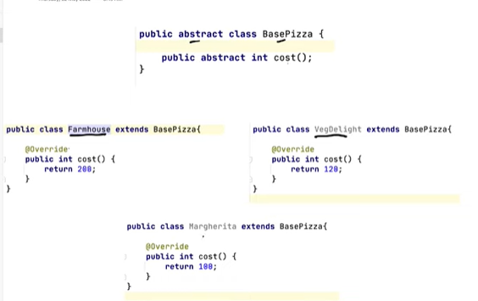
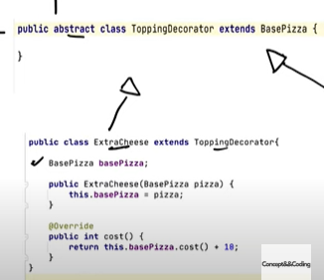
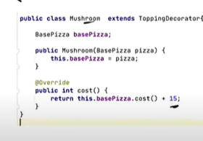

Margarita + extra cheese =>

Basepizza pizza = new ExtraCheese(new Margarita())
Pizza.cost();
=> 100+10 = 110

- Factory pattern vs Abstract Factory Pattern
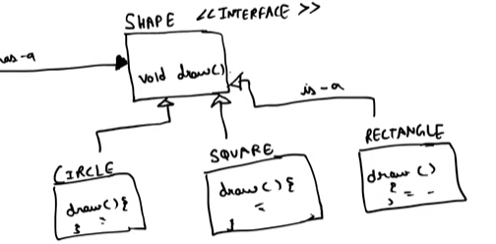
- avoid duplicate

Will return which object it’s actually is,
Is circle, square or rect

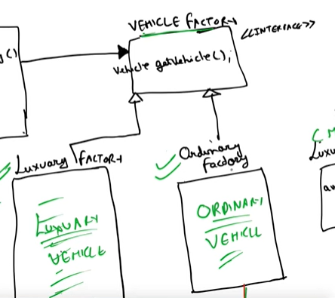

Abstract factory - factory of factory
Luxury - will only return BMW etc
Ordinary will only return swift etc

Examples

- Tic Tac Tor Game:
Object - peace : X, O : should be scallable.
Board - N*M
Players -
Piece
PieceType

Ctor(PieceType t){
}
PieceX : Piece
PieceO : Piece
Board
Int size
Piece[][]board;

Ctor(int size){
This.size = size;
Board = new Piece[size][size];
}

PieceType:Enum{
PieceX,
PieceY
}
Player
String name;
Piece piece;
TicTacToeGame
Deque<Player> players;
Board gameBoard;
TicTacToeGame(){
Initialize();
}

Initialize(){
Players = new

}

Implement logic.

- Chain of responsibility design pattern

When - > ATM/ Vending machine, Design Logger(Amazon)

Sender -->request -->Konsa receiver accept karega that we don’t know

Atm -> Withdraw 2000 rupees ->> ATM[200 , 500, 2000]
If not available then return not much amount.

Tethi : Chain of responsibility
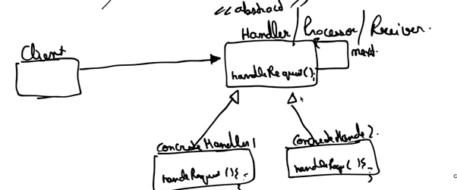

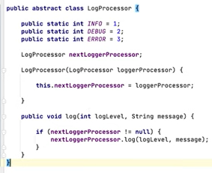
Logger:
Logger obj = new Logger();
Obj.Log(info, msg);
Obj,Log(Debug, msg);
Obj.Log(Error, msg);

